* **Task 2:**

#include<iostream>

using namespace std;

int main(){

int sum,n,num1,commonDifference;

cout<<"enter the first number of sequence there ";

cin>>num1;

cout<<"enter the common difference there ";

cin>>commonDifference;

cout<<"enter the total number of terms there ";

cin>>n;

sum=(n*(2*num1+(n-1)*commonDifference))/2;

cout<<"the sum of the given arthematic sequence is "<<sum;

return 0;

**}**

**Output:**

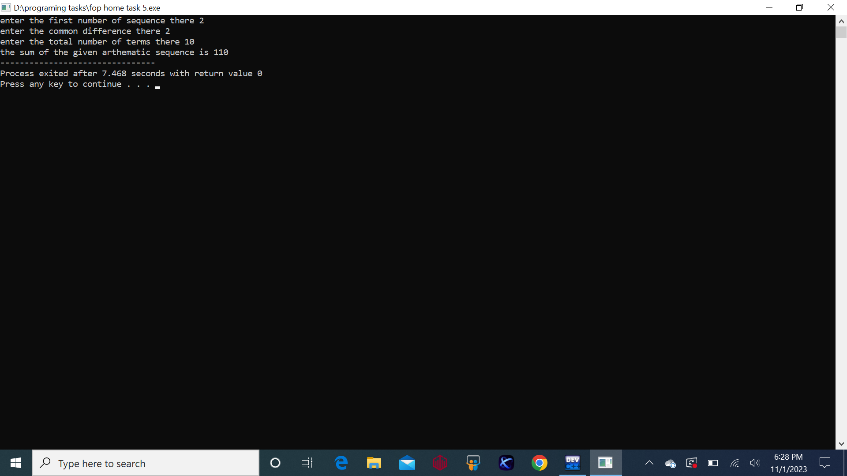

* **Task 1:**

#include<iostream>

using namespace std;

int main(){

int num1,num2,hcf,lcm;

cout<<"enter the first number there ";

cin>>num1;

cout<<"enter the second number there ";

cin>>num2;

for(int i=1;i<=num1 || i<=num2; i++){

if(num1%i==0 && num2%i==0 ){

hcf=i;

}

}

lcm=(num1*num2)/hcf;

cout<<"the LCM between two numbers using HCF is is "<<lcm;

return 0;

}

**Output:**

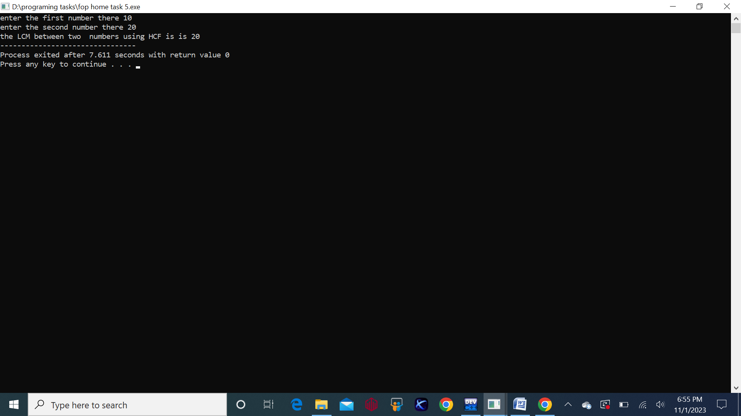

* **Task 3:**

#include<iostream>

using namespace std;

int main(){

int rows;

cout<<"give the number of rows of which you want to print the diamond ";

cin>>rows;

if(rows%2==0){

cout<<"please select an odd number of rows to make a proper shapae ";

return 1;

}

for(int i=0;i<rows/2+1;i++){

for(int j=0;j<rows/2-i;j++){

cout<<" ";

}

for(int k=0;k<2*i+1;k++){

cout<<"*";

}cout<<endl;

}

for(int i=rows/2-1;i>=0;i--){

for(int j=0;j<rows/2-i;j++){

cout<<" ";

}

for(int k=0;k<2*i+1;k++){

cout<< "*";

}cout<<endl;

}return 0;

}

**Output:**

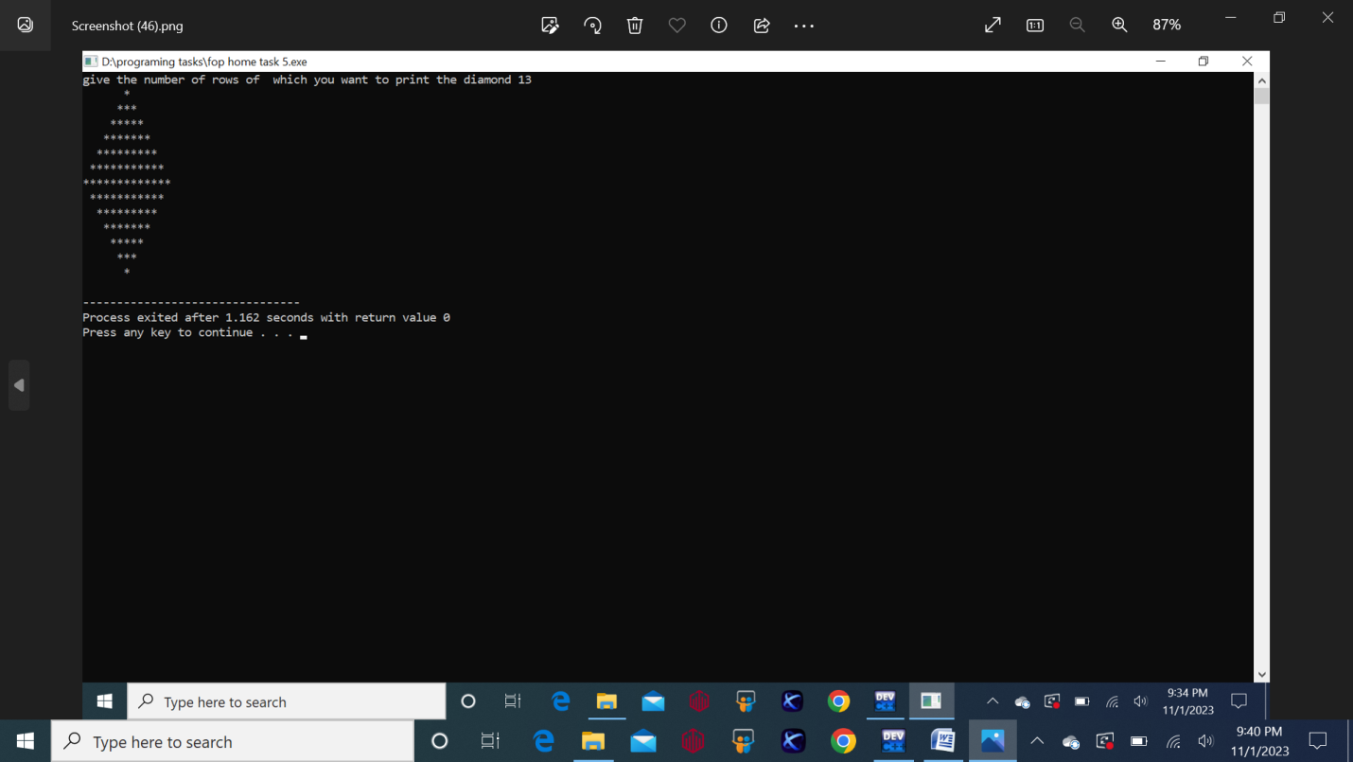

* **Task 4:**

#include<iostream>

using namespace std;

int main(){

int binary=0,num,rem,base=1;

cout<<"enter your desired decimal number to convert it into binary ";

cin>>num;

while(num>0){

rem=num%2;

binary=binary+(rem*base);

num=num/2;

base*=10;

}

cout<<binary;

}

**Output:**

